Low Level Design (EXPENSE CODE module)

Project Code | Team2
Project Name | Expense Management System

Prepared/Modified by | Role | Date of Preparation
Titiksha Kumbhare,Jyotsana Wandhare | Trainee | 05/12/2018
Reviewed by | Role | Date of Review
 |  | 11/12/2018
Approved by | Role | Date of Approval
Circulation List | abhijeet.roshan@capgemini.com  jyotsana.wandhare@capgemini.com  titiksha.kumbhare@capgemini.com  manik.chopra@capgemini.com  divya-shree.vazhavanthan@capgemini.com  rohan.singh@capgemini.com  kamran.khan@capgemini.com  komal.barapatre@capgemini.com | Version Number of the template:1.0
Version Number | 1.0

Table of Contents

1. Description Of The Unit 3
2. References 4
3. Dependencies / Assumptions 5
4. Class Diagrams 6
5. Sequence Diagrams 7
6. Design Components 8
6.1 List Of UI Components 8
6.2 List Of Design Classes 8
7. Re-Usable Routines/Components 9
8. Messages 10
9. Configuration Files 11
10. Crud Matrix Table 12
11. Data Mapping Matrix 13
12. Action Flow Matrix 14
13. Stored Procedures 15
14. Program Specification / Pseudo Code 16
REVISION HISTORY OF THE WORK PRODUCT 17

Description Of The Unit

The add expense module allows the user of the application to add new expense into the database. This module can be used only by the user of the application.

On clicking on the add button in the user home page, the user is redirected to a add page. The user enters all the details of the expense like expense code, expense type, expense description. If the entered expense details are invalid, appropriate error messages are displayed.

After entering all the expense details, the details are inserted into the database on clicking the add button. The user can also cancel the add expense functionality by clicking on the cancel add button.

References

Reference | Description
Repository reference | https://IGTEBLRSVNTNG.igatecorp.com/svn/oct3_Team1
Class Diagram | /Project Documents/Design Documents/HLD/Class Diagrams
URS | /Project Documents/Requirements/Case Study/Ecommerce-grp1 and grp3.doc
UTP | /Project Documents/Test Plan/UTP/Test Cases/AddExpense /UTP_AddExpenseModule.xlsm
DB Design | /Project Documents/Design Documents/HLD/DB Design/E-Commerce_GROUP_DBDESIGN.xls

Dependencies / Assumptions

Assumptions:
The Expense details are stored in the database.

Class Diagrams

Class Diagram

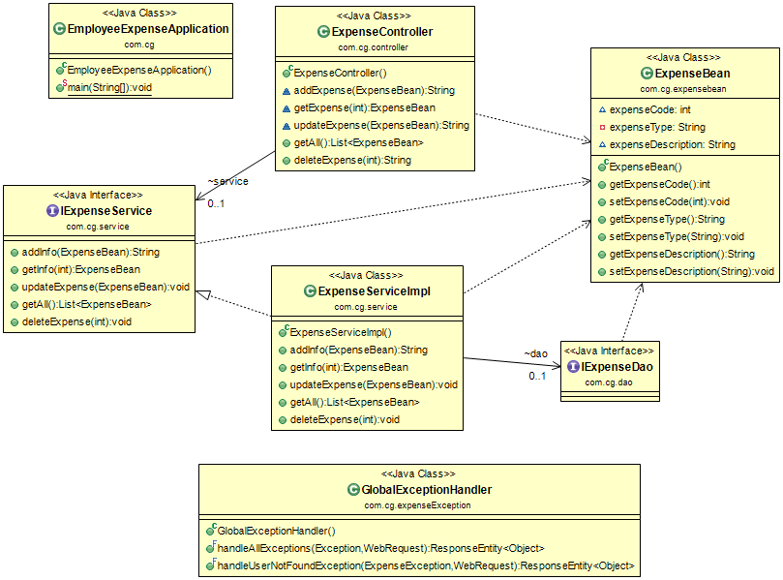

Sequence Diagrams

Sequence Diagram
NA

Design Components

List Of UI Components
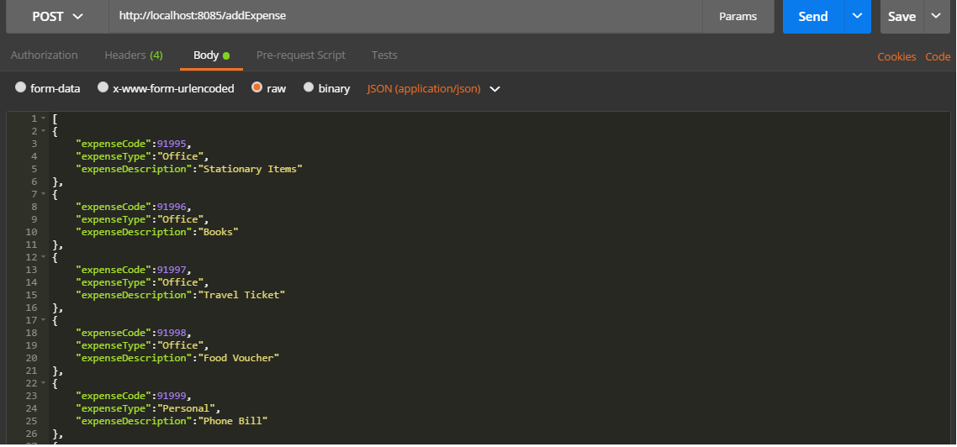
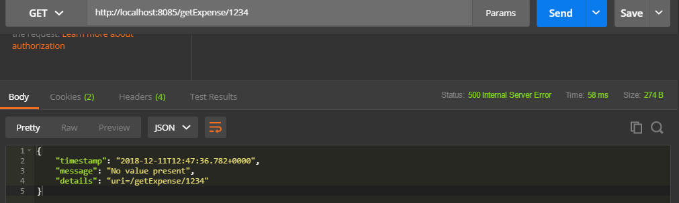

List Of Design Classes

Sr. No. | LLD Name | Class Name | Method Name | Method Description
1 | Add Expense Module | ExpenseBean | Appropriate getters and setters methods | Getters retrieve the property values and setters set the property values
2 | Add Expense Module | ExpenseController | addExpense(@RequestBody ExpenseBean expense) | Sets the model attribute.  addInfo  Calls addInfo() of ExpenseServiceImpl. If it returns object then it redirects to home page else it redirects to add page with appropriate error message.
3 | Add Expense Module | ExpenseServiceImpl | addInfo:Product | Calls save():predefine method of SimpleJpaRepository class and returns the result to controller.  Inserts the expense details into the database and returns the result to ExpenseServiceImpl .

Re-Usable Routines/Components

Re-Usable Routines/Components

- Application property file
- DataAccessException class

Re-Usable Routines/Components
- Application property file
- DataAccessException class

- ExpenseException class
- GlobalExceptionHandler.class

Messages

#. | Type | Message Text
M1 | Error | Enter a valid expense code
M2 | Error | Enter a valid expense Type
M3 | Error | Select a product description
M4 | Error | This field cannot be empty

Configuration Files

File Name | Path | Description
application.yml | EmployeeExpense/src/main/resource | To configure database connection.
pom.xml | EmployeeExpense/ | To configure the dependencies.

Crud Matrix Table

# | Table Name | Create | Read | Update | Delete
1. | Expense | Y | Y | Y | Y

Data Mapping Matrix

Sr. No. | Screen Label | Field Source | Field Type | Data Type | Max Length | Data Flow | Mandatory
1 | Expense Code | Expense Code | NA | int | 11 | UI→D | Yes
2 | Expense type | Expense type | NA | Varchar | 255 | UI→D | Yes
3 | Expense Description | Expense Description | NA | Varchar | NA | UI→D | Yes

Legend
D → UI (Database to User Interface)
UI → D (User Interface to Database)
UI (User Interface Only)

Action Flow Matrix

Sr. No. | Action | Description | Process
1 | On click of Send button of Postman after giving the details in Json form and making the method as POST | Expense Details are inserted | The expense details including expense type is inserted

Stored Procedures

# | Stored Procedure Name  (with Description) | Input/Out Parameters | Type | Size
1. | NA | NA | NA | NA

Program Specification / Pseudo Code

14. 1 ACTION: On click of Send button of Postman after giving the details in Json form and making the method as POST

Pseudo Code:
- Client Side Scripting:
None

- Server Side Scripting:
The project description, start date and end date are inserted.

REVISION HISTORY OF THE WORK PRODUCT
# | Date | Version # | Section Changed | Details of changes made | Approved By
1 | 04/12/2018 | 1.0 | LLD prepared | N/A | Jyotsana Wandhare,Titiksha Kumbhare
2 | 04/12/2018 | 1.1 | Reusable components,  Pseudo code | Reusable components added.  The pseudo code is modified as per the specified flow. | Jyotsana Wandhare,Titiksha Kumbhare
3 | 05/12/2018 | 1.2 | Reusable components,  References,  Data Mapping Matrix. | Reusable Components added.  File name with relative path is added in the references section.  The name of text boxes(screen label is changed). | Jyotsana Wandhare,Titiksha Kumbhare
4 | 05/12/2018 | 1.3 | Configuration files,UI Components | Paths of the configuration files is updated and UI components(Screen Shots) added. | Jyotsana Wandhare,Titiksha Kumbhare

